**4. Evaluation**

This section demonstrates the test and evaluation of each subsystem of Intellitune against the stated technical design constraints. Each of these subsystems ensure that the constraints described in Table 4.1 are met and ensure the functionality of the product.

**Table 4.1 - Technical Design Constraints**

|  |  |
| --- | --- |
| **Name** | **Description** |
| Power Rating | The Intellitune must be capable of handling 1.5 kW of transmitting power. |
| Bandwidth | Tuning circuitry must pass through frequencies in the 1.5 MHz to 30 MHz band. |
| VSWR Sensing | The Intellitune must measure the forward and reflected power to determine the voltage standing wave ratio (VSWR) for up to a 32:1 mismatch. |
| Frequency Sampling | The microcontroller must sample the transmitting signal and determine the frequency up to the maximum 30 MHz limit. |
| Impedance Matching | The Intellitune must provide a tuning network that is capable of matching antenna impedances from 12-1600 ohms. |

**4.1 Test Certification - User Interface**

The user interface of Intellitune is located on the front panel and comprised of the LCD display and push buttons. The LCD display will show the user the SWR reading, forward and reflected power, and the frequency. The user can send a command to the microcontroller by pressing the appropriate button out of the 7 shown in Figure 4.1. The available buttons are Tune, Inductance-Up, Inductance-Down, Capacitance-Up, Capacitance-Down, Antenna, and Mode.

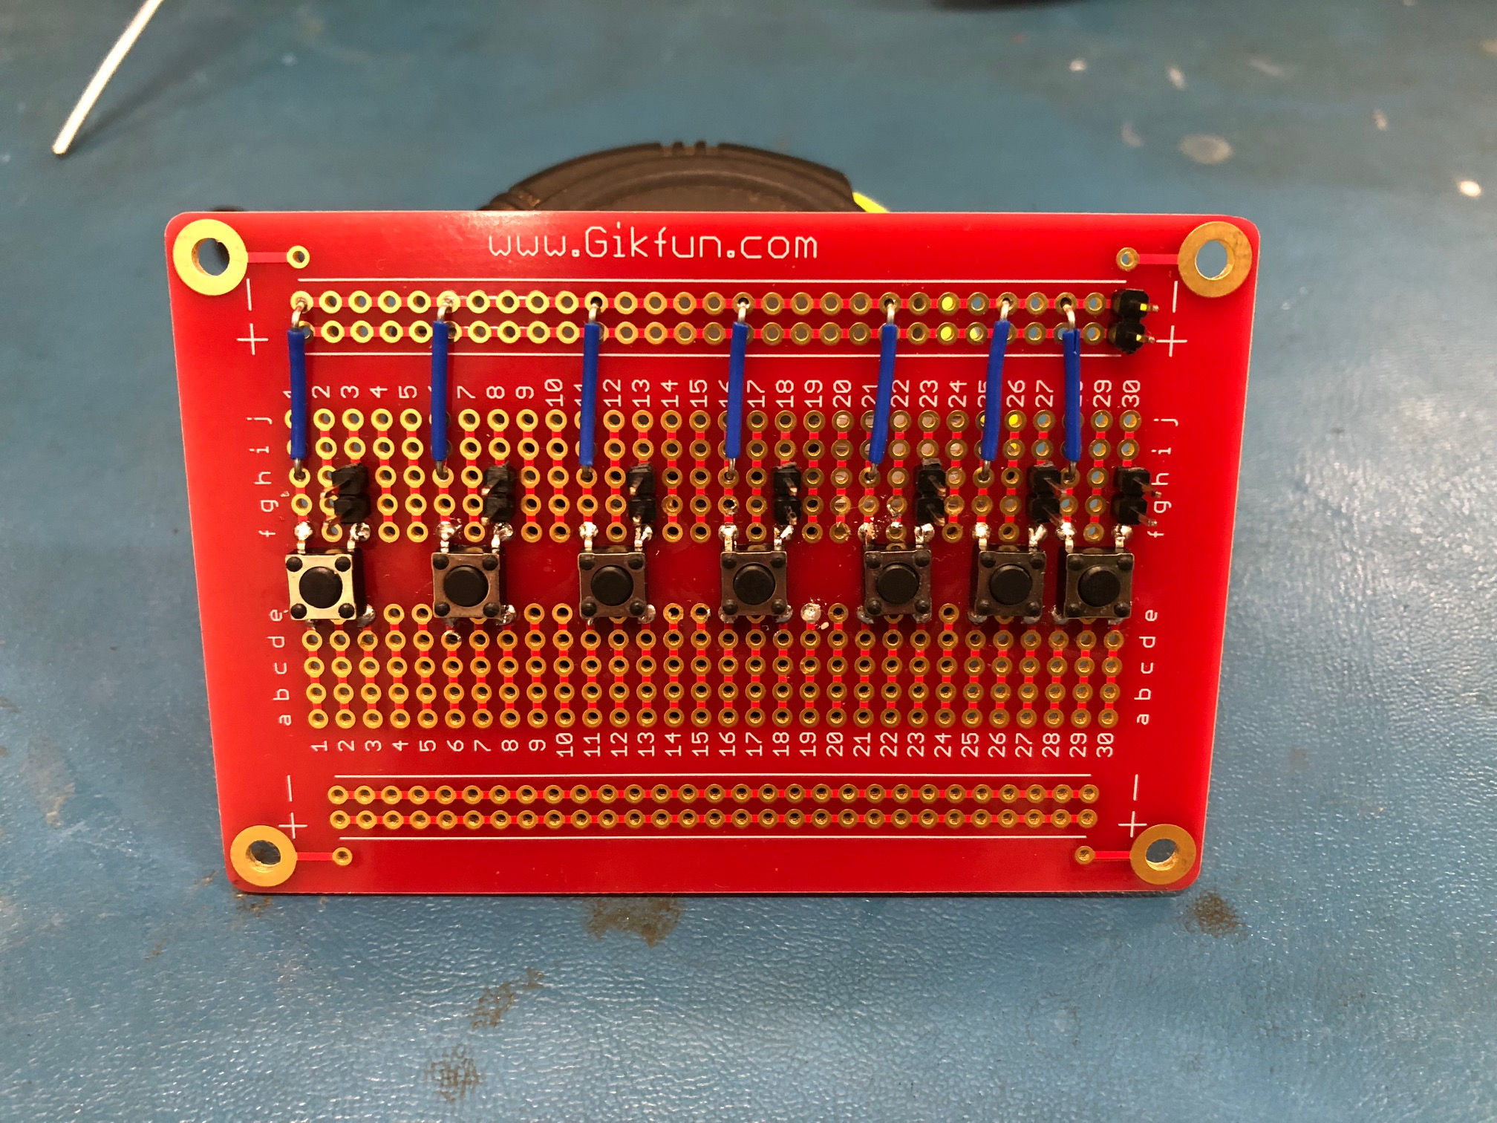

**Figure 4.1 - Push Button Test Circuit**

**4.2 Test Certification - Wideband Current Transformer**

The wideband current transformer is an essential design constraint for sensing the voltage standing wave ratio (VSWR).

**4.3 Frequency Counter Testing**

The frequency counter subsystem utilizes the frequency counter circuit and the microcontroller to satisfy the technical constraint of sampling the transmitted signal and determining the frequency up to 30 MHz. For testing, the waveform generator in Figure 4.2 was used to send a square wave signal to the microcontroller at various frequencies. The calculated frequency was then displayed on the LCD. Test results of the frequency counter are shown in Table 4.2. The frequency counter was found to be accurate up to 3 decimal places as shown in Figure 4.3.

**Table 4.2 - Frequency Counter Test Data**

|  |  |
| --- | --- |
| **Frequency Generated** | **Frequency Measured** |
| 1 MHz | 1 MHz |
| 5 MHz | 5 MHz |
| 10 MHz | 10 MHz |
| 15 MHz | 15 MHz |
| 19.985 MHz | 19.985 MHz |

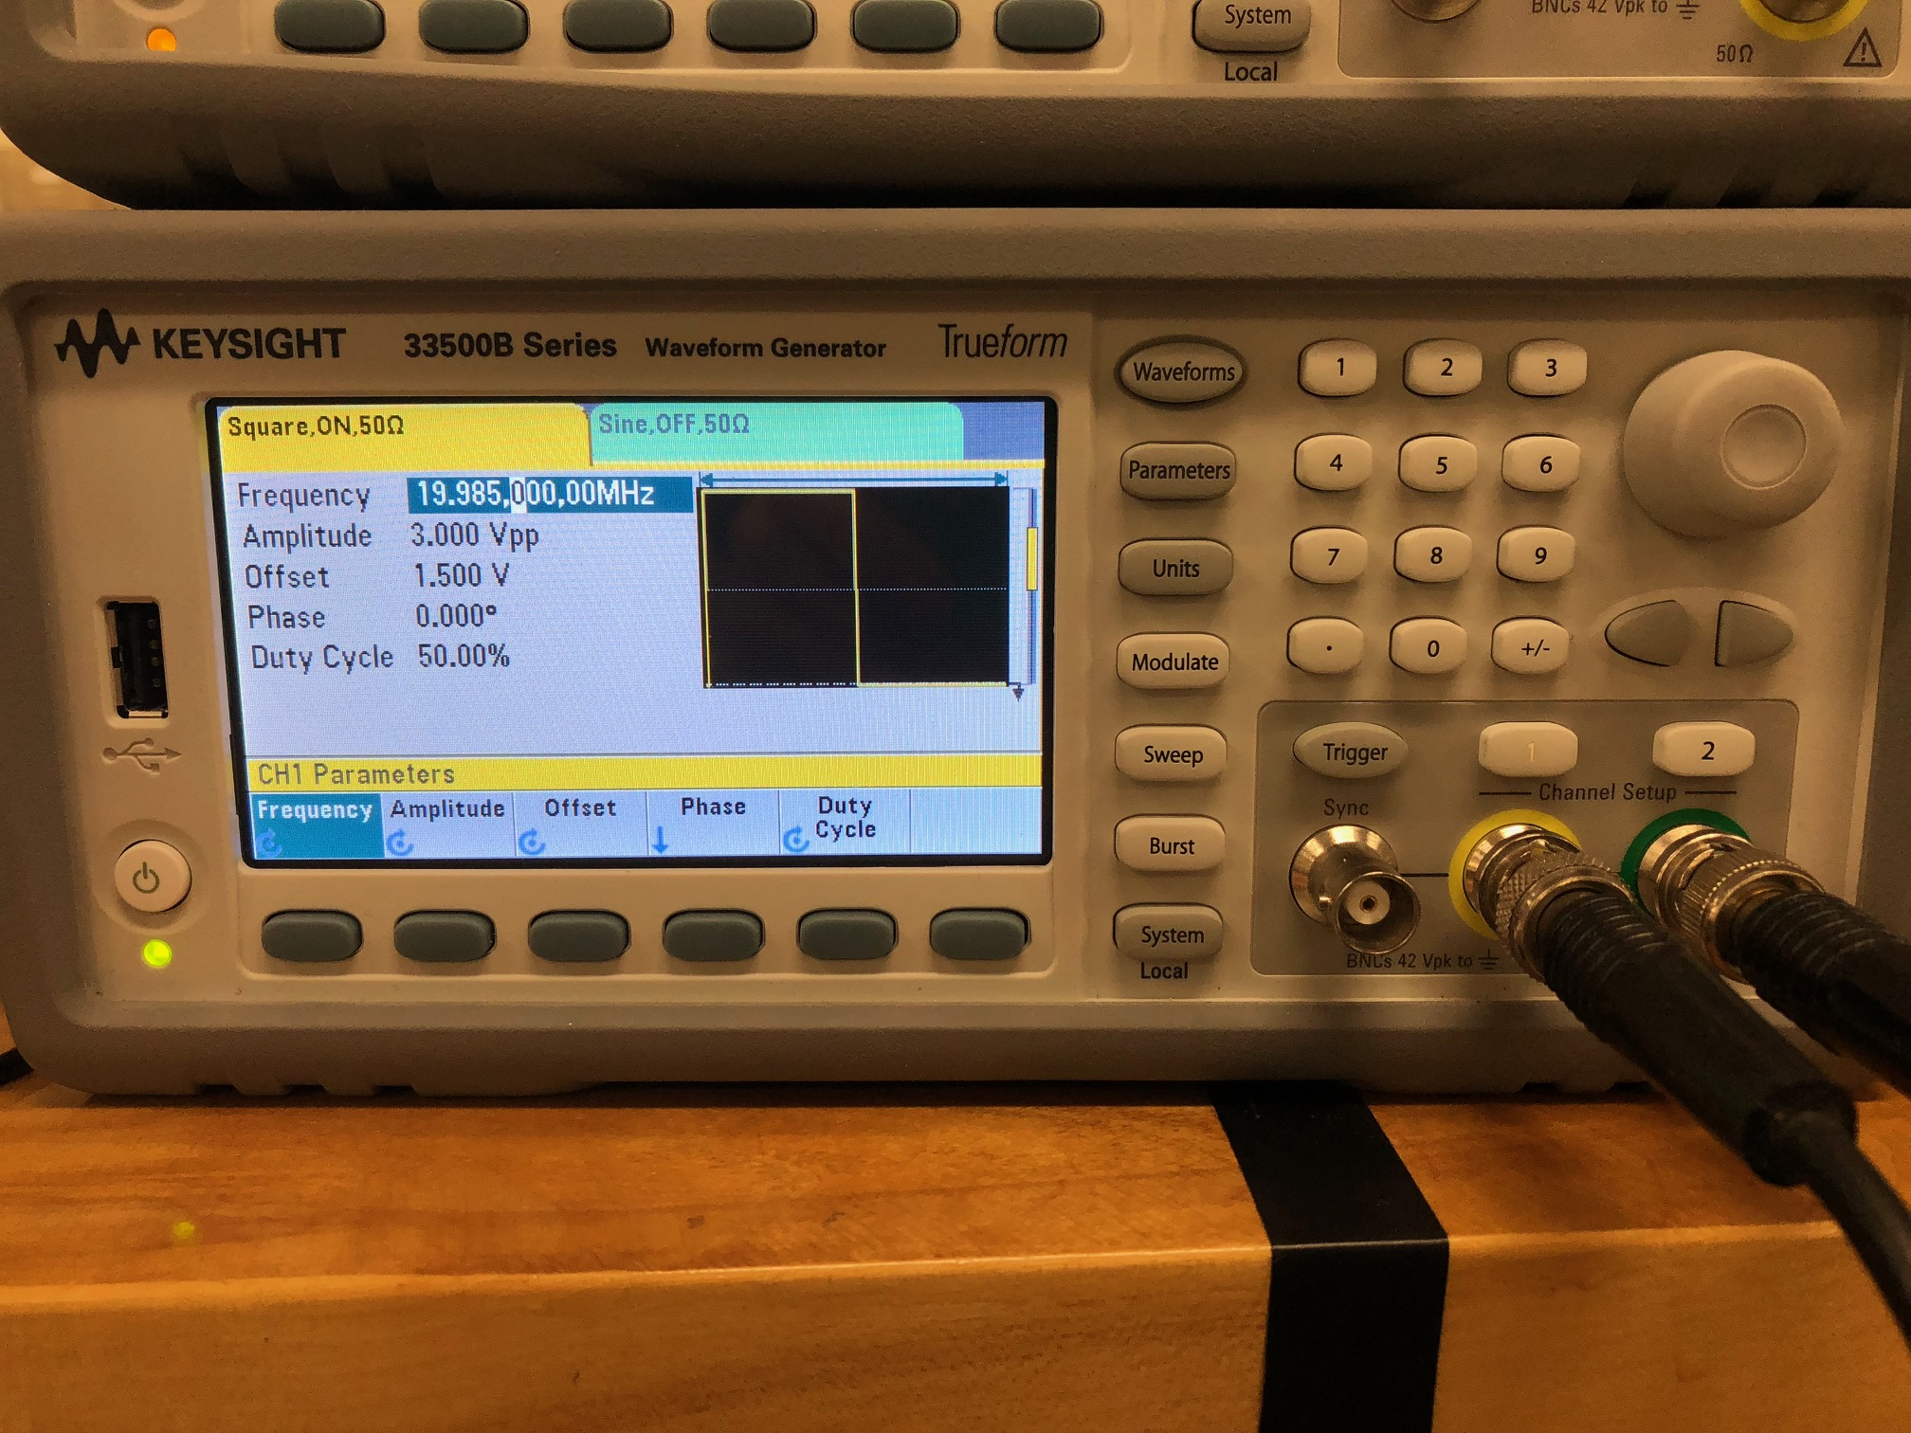

**Figure 4.2 - Waveform Generator Test Setup**

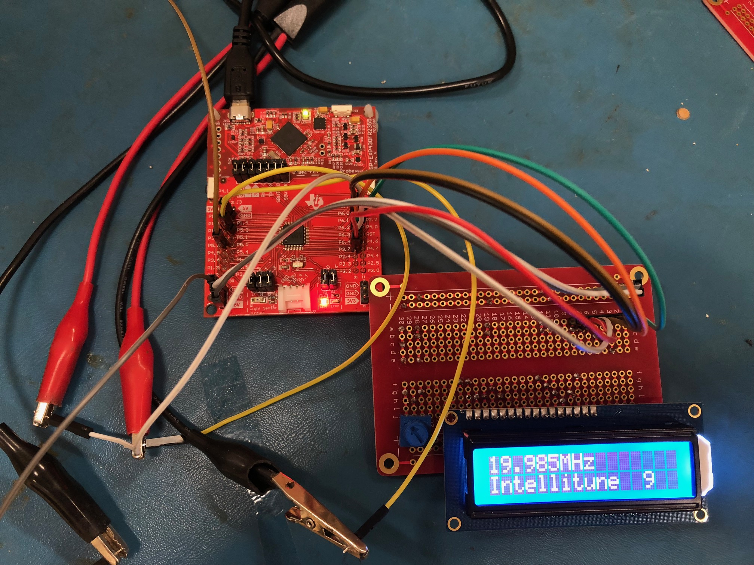

**Figure 4.3 - Test Results of 19.985 MHz Sampled Frequency**

**4.4 Test Certification - Stepper Motor Subsystem**

The stepper motor subsystem consists of the driver code on the microcontroller, two stepper motors, and two stepper motor drivers. Together, these components adjust the variable inductor and the variable capacitor to achieve the needed impedance. Figure 4.4 displays the capacitor stepper motor and its mounting setup. The driver circuit for the capacitor is shown in Figure 4.5.

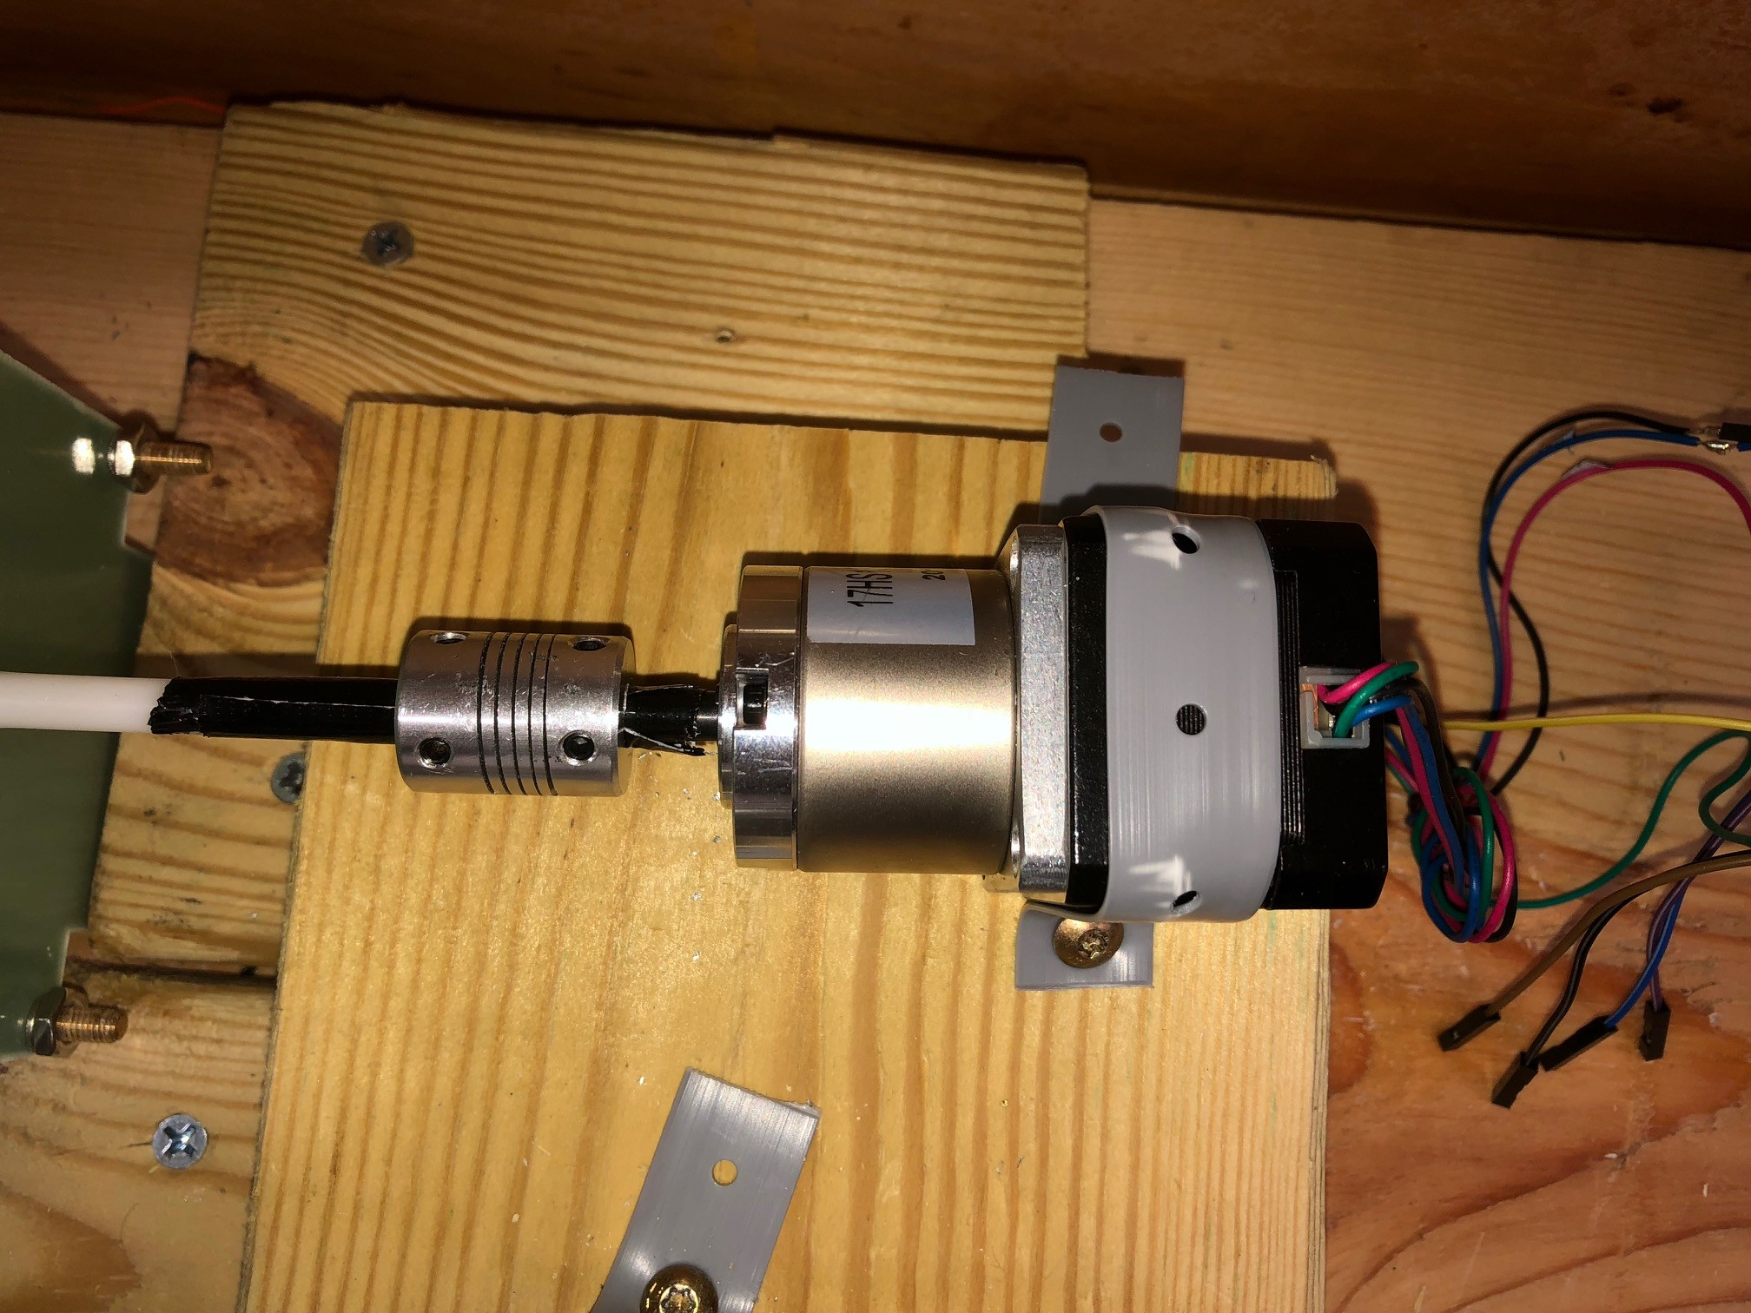

**Figure 4.4 - Stepper Motor Test Setup**

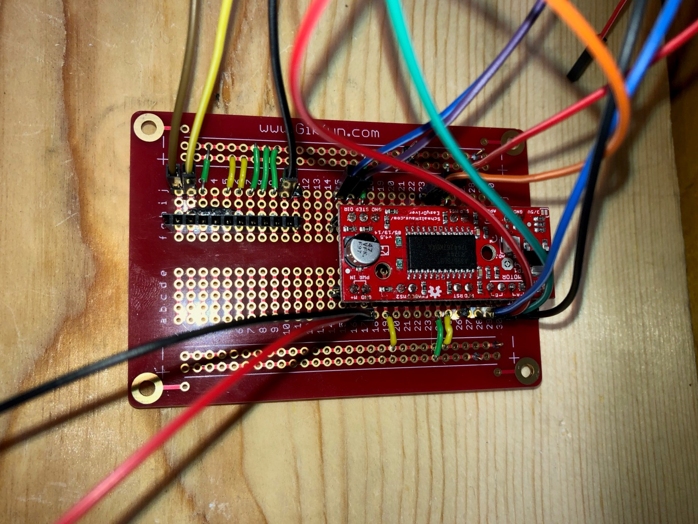

**Figure 4.5 - Stepper Motor Driver Test Circuit**

**4.5 Test Certification - Impedance Matching Code**

The microcontroller executes the impedance matching code to satisfy the design constraint of providing a tuning network that is capable of matching antenna impedances from 12 to 1600 ohms.

**4.6 Test Certification - Variable Component Location Sensing Subsystem**

The purpose of this subsystem is to identify the physical location of the variable components and utilize this knowledge in the tuning process. In order to know how many degrees the stepper motors must rotate to achieve an impedance match, it is first necessary to know where the starting point is. The microcontroller will keep track of the location using a gear on the shaft of the variable components that is connected to a potentiometer. As the potentiometer changes values, the microcontroller uses those values to determine the location that corresponds.

**Table 4.3 - Location Sensing Test Data**

|  |  |  |  |  |
| --- | --- | --- | --- | --- |
|  | **Inductor test 1** | **Capacitor test 1** | **Inductor test 2** | **Capacitor test 2** |
| **Manually turn** | 18 degrees | 18 degrees | 18 degrees | 18 degrees |
| **Measured Impedance** | X uH | X pF | X uH | X pF |
| **uC reading on position** | X degrees | X degrees | X degrees | X degrees |
| **uC reading on Impedance** | X uH | X pF | X uH | X pF |
| **Pass or Fail** |  |  |  |  |

**4.7 Test Certification- Power Handling Capability**

The final Intellitune must be capable of handling 1.5 kW. For the prototype this semester, the aim is to operate at 50 W.